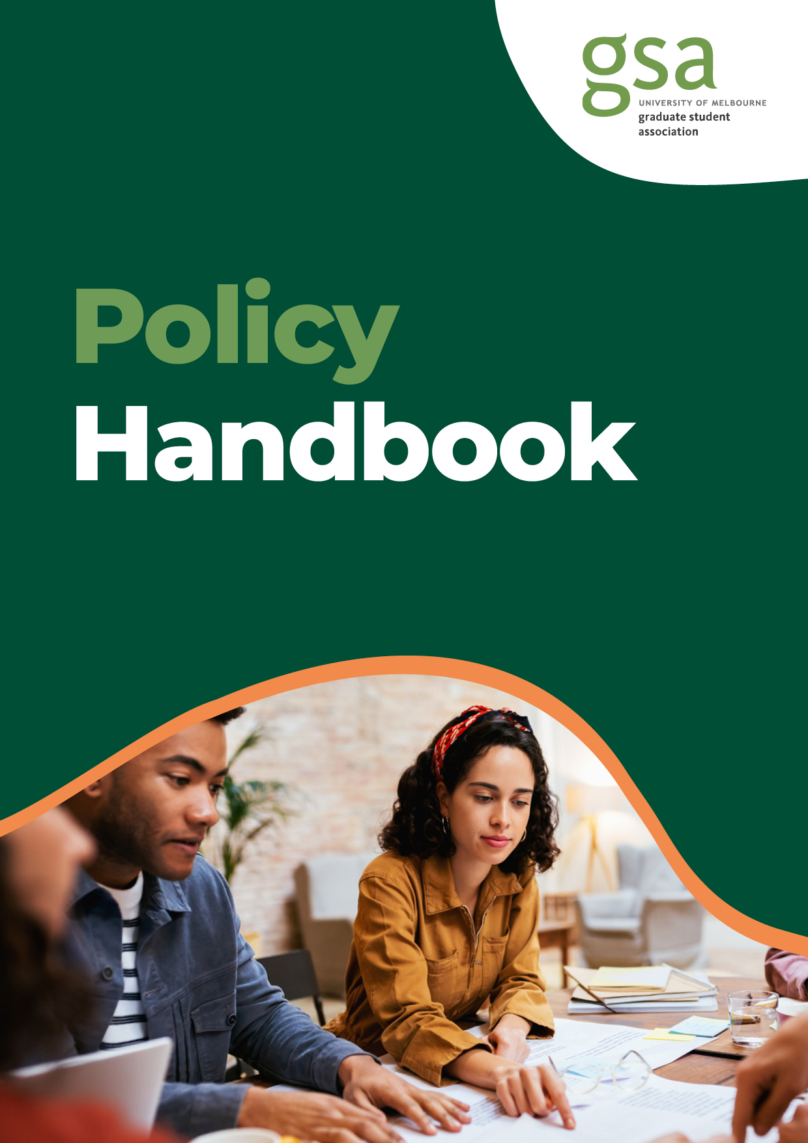
Policy Handbook
This handbook was written on the Land of the Wurundjeri People of the Kulin Nation. GSA acknowledges the Wurundjeri People as the traditional custodians of this land and pays respect to elders past and present. We acknowledge that sovereignty was never ceded and this land always was and always will be Aboriginal land.
GSA Introduction
The Graduate Student Association (GSA) is the independent representative organisation for all graduate coursework and research students at the University of Melbourne. We are led by 8 GSA Board members, 12 Representative Council members and 18 Faculty Council members who are all elected University of Melbourne graduate students. On behalf of over 40,000 constituents, we represent graduate student interests to the University and wider community, provide student engagement events, activities, and information to the graduate student community, and support 150 affiliated graduate student groups.

Policy & Advocacy Introduction
The Policy & Advocacy team at GSA works to help create better change for graduate students at the University of Melbourne. With the help of the Representative Council and other student-facing representative groups, the Policy & Advocacy team has advocated for better outcomes for students since 1994, to the University of Melbourne, the government, the education sector and the wider student community. The Policy & Advocacy team works to improve student life, advocate for graduate students and push for positive change at both the University and government level.

To find out more about our work, or to let us know about an issue you are facing,
please contact the Policy & Advocacy team at policy_advocacy@gsa.unimelb.edu.au

Policy Handbook: Overview
The Policy Handbook provides an overview of the Policy & Advocacy team’s recent advocacy work. This includes key advocacy areas where the Policy & Advocacy team has been successful in advocating for change on behalf of the graduate student community at the University of Melbourne.
The Policy & Advocacy team’s advocacy initiatives have included reports, submissions to various government inquiries, as well as submissions to the University’s different policy consultations, among other advocacy measures. The topics of the Policy & Advocacy team’s advocacy initiatives have centred around several themes, including:
1 | Access and Equity
2 | Cost of Living
3 | Covid 19
4 | Learning and Teaching
5 | Health and Wellbeing
6 | LGBTQIA+
7 | Graduate Research
8 | Safety
This handbook will provide an overview of the Policy & Advocacy team’s various advocacy initiatives between 2020 to 2024 within each of these themes.

This overview highlights the broad work of the Policy & Advocacy team in representing better outcomes for graduate students and ensuring that graduate student needs are recognised across the University of Melbourne, as well as across Local, State and Federal Government initiatives.

Advocacy submissions, reports and documents can be found on the Policy and Advocacy homepage on the GSA website, where additional information on the Policy and Advocacy team and GSA can also be found.

Access and Equity
The Policy & Advocacy team has been working on access and equity advocacy initiatives to ensure that the University is truly accessible to
the diverse needs of the graduate student cohort.

This includes advocating for access and equity regarding graduate student parents and graduate students with a disability, as well as diversity and equity more broadly.

Submission to the Student Equity and Disability Services (SEDS) review (2023)
The submission to the University’s Student Equity and Disability Services (SEDS) review highlighted the various challenges graduate students with a disability face at the University. The submission included several anonymous testimonies from graduate students and demonstrated the difficulty some graduate students can face in accessing adequate support due to the complex processes at the University. The Policy & Advocacy team used the submission to advocate for a more empathetic, efficient and streamlined approach to SEDS to meet the diverse needs of the graduate student community. Key recommendations from the submission included:
- The University expand training such as medical training and legitimises flexible learning options and remote exams.
- The University audits how faculties implement AEAs to ensure that they are in-line with the expectation of SEDS, medical practitioners and legal obligations regarding access and inclusion.
Other initiatives from the Policy & Advocacy team surrounding access and equity issues have included:
- Conversion of student start-up scholarships to loans.
- Consultation for TEQSA guidance notes on diversity and equity, student grievances and complaints, and wellbeing and safety.
- GSA Assistive Technologies Library Accessibility Survey Report.
- Submission to the Inquiry into the Recognition of Unpaid Carers.

Parents on Campus Report (2020)
A survey of graduate student parents at the University of Melbourne was undertaken to better understand the challenges facing this cohort and inform a report on the issue. The results of this survey identified several challenges which were detailed in the final report including a lack of family-friendly support, inadequate University policies, costly and inaccessible childcare, as well as a sense of invisibility and alienation among graduate student parents. Key recommendations from the report included:
- The Federal Government increase leave entitlements for graduate research students who are parents, raise government payments for graduate researchers, and reform the Child Care Subsidy scheme to better support student parents.
- The University ensure that policies align with student parent needs and that these policies are implemented appropriately, as well as increase access to University childcare and provide more family-friendly support and physical spaces.
- GSA lobby the University and the Federal Government, continuing to advocate for changes and consult regularly with graduate student parents.

Cost of Living
The Policy & Advocacy team has advocated for graduate students who are experiencing difficulties due to the high cost of living in Melbourne. This advocacy has included addressing the broad challenges associated with graduate students and the cost of living, as well as the rental crisis, and experiences with poverty and food insecurity. This advocacy has demonstrated the impacts to decision-makers, both immediate and long-term, of the cost of living on graduate students at the University of Melbourne.
Submission to the inquiry into food security in Victoria (2024)
The submission detailed the drivers and impacts of food insecurity among graduate students at the University of Melbourne, as well as the barriers they faced when accessing food relief. The submission made several recommendations which focused on increasing the food security of graduate students, including recommending that:
- The Victorian Government partner with relevant food organisations to provide food relief to vulnerable graduate students, including designing specific programs to support international graduate students.
- The Victorian Government encourage Victorian Universities to provide improved food options and food relief on campus.
The Policy and Advocacy team were invited to expand on the findings of the submission at the inquiry’s public hearing at the Parliament of Victoria. The Legislative Council Legal and Social Issues Committee tabled its final inquiry report in November 2024 and several of the Policy & Advocacy team’s recommendations were reflected in the report’s final recommendations.

Submission to the Select Committee on the Cost of Living (2023)
The submission outlined the challenges relating to the high cost of living that have impacted graduate students at the University of Melbourne. The submission highlighted the increase in student poverty due to the increasing cost of living in Melbourne. The submission made several recommendations, including that:
- The Federal Government increased the Research Training Program (RTP) stipend rate to align with the minimum wage and extended income support payments to provide graduate students with some relief from cost of living expenses.
The Policy & Advocacy team also provided a supplementary submission to the Committee in 2024, which reflected additional insights from the graduate student community at the University regarding the impacts of the cost of living. The supplementary submission provided additional information about graduate students’ financial circumstances, as well as the overall impacts the cost of living is having on the lives and futures of graduate students.

Submission to the Senate inquiry into the extent and nature of poverty in Australia (2023)
The submission explored how the high cost of living and academic structures can drive graduate students into poverty. The submission highlighted the prevalence of food insecurity and the need for the provision of material aid as evidenced through attendance at GSA’s food providing programs. The submission advocated for systemic change and increased support to alleviate poverty among graduate students.

Submission to the inquiry into the worsening rental crisis in Australia (2023)
Based on the results of a rental experiences survey for graduate students at the University of Melbourne, this submission explored the rental experiences of this cohort. 80% of survey respondents reported a lack of affordability among rentals. Respondents also reported difficulty in earning the income required to maintain a rental property. The worsening rental crisis was identified as impacting their physical and mental health. The submission highlighted the challenges graduate students can face in the rental market. These challenges include affordability, limited rental options, financial instability and impacts on overall wellbeing. The submission acknowledged that those who are new to Australia may find navigating the rental market even more challenging due to their lack of rental history. The submission made recommendations on these issues, including:
- Increasing the rate of the RTP stipend, providing enhanced government support and educating real estate agents.
The Policy & Advocacy team also developed and launched a Rental Housing Toolkit to assist graduate students to navigate the rental market in Victoria.
Other initiatives from the Policy & Advocacy team surrounding cost of living issues have included:
- Public transport concessions for graduate students - the Fares Fair campaign.

Covid-19
The Policy & Advocacy team has been advocating for graduate students in relation to the impact of Covid-19 and calling for adequate support to be provided to graduate students during the pandemic. This advocacy has included research on the impact of Covid-19 on graduate students, as well as advocating for international graduate students who faced unique challenges during the pandemic.
Student Resilience Project (2021)
The action research Student Resilience Project identified several difficulties and challenges facing graduate students, including the impact of Covid-19. These challenges included difficulties in accessing support services, insufficient mental health resources, study changes and other pandemic-related impacts such as stress and financial hardship. The results of the Project highlighted that during the Covid-19 pandemic there was a pressing need for improved support services, and initiatives to foster a sense of belonging. The Project provided recommendations to the University, including:
- The University improve mental health awareness and literacy among students, as well as deliver extension and special consideration processes that are student centred and not punitive.
Submission to the Select Committee on Temporary Migration (2020)
The Policy & Advocacy team’s submission to the Select Committee on Temporary Migration supported government visa changes that were beneficial to international students. The submission recommended:
- The Federal Government further assess visa requirements, as well as allow increased working hours for international students to safeguard international students reporting workplace issues and provide comprehensive support during the Covid-19 pandemic.
Submission to the Select Committee on Covid-19 (2020)
The submission to the Select Committee on Covid-19 highlighted the impacts of the pandemic on graduate students, both domestic and international, at the University of Melbourne. The submission recommended that:
- The Federal Government create a federal fund to financially support international students, temporarily ease work restrictions and introduce a temporary visa extension to international students.
Other initiatives from the Policy & Advocacy team surrounding Covid-19 issues have included:
- GSA student issues digest 11-27 May 2020.
- Impact of Covid-19 on graduate student placements.

Learning and Teaching
The Policy & Advocacy team has been working on issues relating to education, including matters relating to course delivery, assessment policy and academic support. The Policy & Advocacy team has advocated for a student-centred approach in all matters relating to education.

Placement: Student perspectives, concerns and priorities for change (2024)
GSA’s Education (Coursework) Officer developed this report in partnership with the Policy and Advocacy team. The report highlighted the challenges graduate students can face when undertaking a placement as part of their studies. The challenges identified in the report include graduate students on placement facing a lack of preparation to undertake placement, demotivation to report negative experiences such as bullying or sexual misconduct and threats to student wellbeing. The report included several recommendations to the University, including that:

- The University ensure students are informed of appropriate reporting and support channels (e.g. – Safer Communities) prior to starting a placement.

- The University advocate for paid placements with placement providers and government, so that students can be adequately supported to undertake placement.

- The University use student feedback data to assess values, skills and practices for potential provider models.

Response to Australia Universities Accord Interim Report (2023)
The written response to the Australian Universities Accord Interim Report detailed the perspectives of graduate students at the University of Melbourne, including areas of agreement and disagreement with the Interim Report. The Policy & Advocacy team’s response supported the student-centred approach of the report but also noted that students should be involved throughout every stage of input and decision making. The report included several recommendations, including:

- That online learning options should be a priority for higher education providers.
- Student retention should be used as an additional measure of how well supported students are and subsidised places for international students could be offered for certain courses.

Dual Delivery Learning Recommendations (2022)
The recommendations advocated to the University for dual delivery learning to enhance inclusive learning and teaching. These recommendations included that:
- The University enhance the training and professional development of academic staff and provide technology support for academic staff during large classes.
- The University equip classrooms with high-quality technology, raise awareness about Student Equity and Disability support and better address stigma around online participation.
Submission to the Amendments to Assessments and Results Policy (2021)
The submission detailed the perspectives of graduate students in response to proposed grading changes. The submission advocated for a more inclusive and transparent grading system, and recommendations included:

- The University adopt the ‘High Distinction/Distinction/Credit/Pass’ grading scale and present median scores separately.
- The University ensure ongoing student-centric consultation is pursued for all decision-making related to student outcomes.

Academic Skills Submission (2021)
Established in response to proposed changes at the University of Melbourne’s Academic Skills Division, the submission explored the needs of graduate students in relation to these changes. The submission stressed the need for alignment of staff advisor hours with students’ requirements. The submission noted that graduate students were facing wait times for one-on-one appointments and that reducing advisor capacity may fall short of meeting the demands of graduate students. The submission included several recommendations, including that:
- The University evaluate the demand for one-on-one Academic Skills appointments and increase staff hours accordingly.
- The University proactively conduct consultations with the Pandemic Reset Program to seek and consider student perspectives.

Strengthening International Students Access to University Support Services (2021)
The reported highlighted the experiences of international graduate students had in accessing the University's support services. The report detailed international graduate student challenges including limited awareness of University services, inadequate support for offshore students and language barrier issues. The report ultimately recommended that:
- The University work to increase awareness of University services, improve counselling services, increase support and wellbeing programs for offshore graduate students and recognise cultural diversity.
- The University provide cultural competency training within support services and incorporate student feedback for continuous improvement.
Other initiatives from the Policy & Advocacy team surrounding learning and teaching issues have included:
- Subject Cancellation Survey.
- Submission to the International Education Strategy 2021-2030 Consultation.
- Consultation for TEQSA guidance notes on facilities and infrastructure, academic monitoring, and academic and research integrity.
- Consultation for assessment reform in the age of artificial intelligence.
- Consultation on course design, learning outcomes and assessment, learning resources and educational support.
- GSA’s response to proposed changes to special consideration.
- Faculty of Law seminar recordings.
- Study spaces for graduate students.
- A Framework for Educational Excellence at the University of Melbourne.
Health and Wellbeing
The Policy & Advocacy team has advocated for graduate students in relation to the theme of health and wellbeing, particularly regarding graduate student carers.
Submission to the inquiry into the recognition of unpaid carers (2023)
The submission detailed the challenges that graduate students who engage in unpaid care work can face. These challenges relate to financial stress, childcare accessibility and a lack of University recognition as well as from society more broadly. The recommendations from the submission included:
- The streamlining of support, as well as providing financial support, providing material aid and increasing the RTP stipend.
Other initiatives from the Policy & Advocacy team surrounding health and wellbeing issues have included:
- 2020-21 Pre-budget submission.
- 2021-22 Pre-budget submission.
- Submission to Consultation on free speech amendments to the Higher Education Support Act.
LGBTQIA+
The Policy & Advocacy team has sought to ensure better outcomes for LGBTQIA+ graduate students. This has been achieved through advocacy relating to the experiences of LGBTQIA+ graduate students at the University of Melbourne, as well as submissions to the University during policy consultations.
Graduate LGBTQIA+ Inclusion Findings (2021)
The Policy & Advocacy team produced a report detailing the results of a survey of graduate LGBTQIA+ students. The recommendations within the report included:
- The University instigate transformative change and foster a more supportive community for everyone within the academic sphere.
- The University raise awareness about LGBTQIA+ University services and resources, as well as increasing social connectedness, ensuring safety, enhancing intersectional representation and developing awareness of LGBTQIA+ issues in the University community.
Submission to the University of Melbourne gender affirmation policy consultation (2021)
The submission focused on advocating for an inclusive University environment where all identities are respected and valued. Student representative feedback informed the submission, as representatives emphasised the need for clarity, cultural sensitivity and robust support for students undergoing gender affirmation. The submission’s recommendations included that:
- The University provide a gender affirmation plan template and specify where students can get help to develop a gender affirmation plan.

- The University expand the policy to clearly definite terminology including the terms transgender, gender diverse and non-binary, as well as proving a plain language definition of the term gender affirmation.

Graduate Research
The Policy & Advocacy team has advocated for research graduate students at the University, including through representing the needs of graduate researchers and consistently advocating for the rate of the RTP stiped to be increased.
Authorship Policy Submission to University of Melbourne (2022)
The submission presented findings that support the University of Melbourne streamlining and enhancing the University’s Authorship Policy. These key findings centred around the themes of administrative burdens, the need for a decision map, coordinating authors and implementation challenges. The submission’s predominant recommendation was:
- The University produce policy and templates centrally, as well as develop a decision map and flowchart to provide clarity.
Graduate LGBTQIA+ Inclusion Findings (2021)
The report outlined the concerns of coursework graduate students participating in research subjects. The report included the suggestions of coursework graduate students on improving the overall quality of courses. The report recommended several improvements to the academic experience of coursework graduate students undertaking research including:
- Improving the quality of research methods training.
- Improve supervisor relationships by increasing the number of supervisors and implement consistent assessment policies.
Engagement with graduate students and graduate researchers (2022)
The Graduate Students and Researchers Engagement Report provided insights into the perceptions of graduate researchers on the quality of research supervision and perspective on the University. This report also detailed the perspectives of the graduate student community and identified key areas for improvement. The report recommended that:
- The University improve student-supervisor relationships and supervisor agreements, as well as review the University complaints process and establish a sensible maximum number of graduate researchers for each supervisor

Academic Progress Review in Graduate Research Courses Policy (2021)
The Policy & Advocacy team provided a detailed analysis of the Academic Progress Review in Graduate Research Courses Policy. The analysis outlined the impact of the Policy on graduate researchers. The analysis found that the Policy had a rigid framework which may increase administrative burdens, hindering the quality of work. Furthermore, the Policy had inadequate provisions for graduate researchers deemed at risk due to compassionate and compelling circumstances. Recommendations included:
- A moratorium on significant policy changes, comprehensive consultation, flexible processes and enhanced support services to ensure a more student-centred approach.
Submission to Senate inquiry into unlawful underpayment of employees’ remuneration (2020)
The submission explored how wage theft affected University staff and students. Recommendations from this submission included that:
- The Federal Government pay a living wage stipend to graduate researchers, raise the RTP stipend to align with the minimum wage and ensure that entitlements, including superannuation, are provided.
Other initiatives from the Policy & Advocacy team surrounding research issues have included:
- Submission on Proposed Amendments to the Management of Research Data and Records Policy.
- Graduate Researchers Report.
- Professional Editors for RHD Thesis.
- RHD timely completion.

Safety
The Policy & Advocacy team has been addressing the issue of safety through advocacy initiatives concerning safety on placement, addressing sexual misconduct prevention and response, as well as strengthening international students access to support services at the University.
Safety on Placement Report (2021)
The report highlighted the gaps in awareness, support and reporting mechanisms for sexual misconduct during student placements. The report advocated for students’ well-being and safety beyond the University’s borders. The report recommended that:
- The University ensure that graduate students are aware of their workplace rights, commit to a prevention strategy, develop mechanisms to ensure safety and remove students from unsafe placements while providing alternative placement opportunities.
Submission to consultation on the University of Melbourne Sexual Misconduct Prevention and Response Policy (2021)
The submission focused on recommending that the University consider enhancing accessibility, promoting inclusivity in policy creation and active student engagement. The submission was focused on shaping a safer, more respectful University environment that is inclusive and supportive for everyone.
Strengthening International Students’ Access to University support services (2021)
The report highlighted the experiences of international graduate students and the challenges this cohort can face in accessing University support services. The report focused on key issues including language barriers, limited awareness of services, inadequate support for offshore students and recommended:
- The University increase awareness of services and provide clear information to international graduate students, as well as increase counselling services, create opportunities for community connection and incorporate cultural competency training within support services.
Other initiatives from the Policy & Advocacy team surrounding safety issues have included:
- Support Now. Always.
- Supporting Safe Schools.
- Speak Safely 2023 Update.
- Consultation for TEQSA sexual harm good practice note.
Contact Us
Call us  Our free hotline  1800-GSA-HELP (1800-472-435)  Our reception desk  (03) 8344 8657 | Find us  1888 Building  The University of Melbourne  Parkville, Victoria 3010
Follow us    /GraduateStudentAssociation    @GSA_UniMelb    @GSA_UniMelb    /gsaunimelb | Email Us  policy_advocacy@gsa.unimelb.edu.au


